**Assignment - 4**

1. **Problem Statement**
   1. **Raymond’s Algorithm -- Diffusion-Computation approach**
2. **Source Code**
   1. **>> Main.java**

/* About Project

This is Raymond’s Algorithm Diffusion-Computation approach using threads

*/

/* About Main

The Main class provided constructs a tree structure from a file based on hierarchical indentation,

using a stack to manage node relationships and a hashmap to store nodes by their IDs.

It includes functionality to prompt the user for a file using AWT's FileDialog, and

prints the tree recursively starting from the root node found in the hashmap.

The main method orchestrates these operations, also implementing threading for each node to simulate concurrent processes,

although the use of reverse order in the TreeMap for threading purposes is unusual unless specifically required by the test scenario.

Overall, while the class showcases tree manipulation and concurrent execution, it appears geared towards testing or demonstration

rather than implementing Raymond's inverted tree-based mutual exclusion algorithm directly.

*/

/* Author

Rahul Biswas, Arijit Mondal

*/

import java.io.BufferedReader;

import java.io.FileReader;

import java.io.IOException;

import java.util.Stack;

import java.util.TreeMap;

import java.util.Comparator;

import java.util.HashMap;

import java.util.LinkedList;

import java.util.List;

import java.util.Map;

import java.awt.*;

public class Main {

// Method to build a tree structure from a file

public static HashMap<Integer, Node> treeBuilder(String filePath) throws IOException {

BufferedReader reader = new BufferedReader(new FileReader(filePath));

String line;

int id = 1;

Stack<Node> precedenceStack = new Stack<>();

HashMap<Integer, Node> treeNodes = new HashMap<>();

// Read lines from the file

while ((line = reader.readLine()) != null) {

// Calculate the level of indentation (assuming 4 spaces per level)

int level = countLeadingSpaces(line) / 4;

String nodeName = line.trim();

Node newNode = new Node(id, nodeName, level);

if (level == 0) {

// If it's a root node, push to stack

precedenceStack.push(newNode);

System.out.println("New Node (leaf) pushed: name: " + newNode.getName() + " id: " + newNode.getId());

} else {

// Connect child nodes to their parents

while (!precedenceStack.isEmpty()) {

Node child = precedenceStack.peek();

if (child.getLevel() < level) {

child.addParent(newNode); // Set current node as child's parent

treeNodes.put(child.getId(), child); // Add child to treeNodes map

precedenceStack.pop(); // Remove processed node from stack

System.out.println("Child Popped: name: " + child.getName() + " id: " + child.getId()

+ " parentid: " + child.getParentID());

} else {

break;

}

}

// Push current node to stack

precedenceStack.push(newNode);

System.out.println("New Node (internal) pushed: name: " + newNode.getName() + " id: " + newNode.getId());

}

id++;

}

int rootCounter = 0;

// Pop remaining nodes from stack to finalize the tree

while (!precedenceStack.isEmpty()) {

Node node = precedenceStack.pop();

node.setStatus(Status.PHOLD); // Set status of node

node.addParent(null); // Set parent of root node to null

treeNodes.put(node.getId(), node); // Add root node to treeNodes map

System.out.println("Root Popped: name: " + node.getName() + " id: " + node.getId() + " parent Id: " + node.getParentID());

System.out.println();

System.out.println();

System.out.println("System Log:");

System.out.println("Information Message: Node " + node.getName() + " with ID " + node.getId() + " have been set to PHOLD initially.");

rootCounter++;

}

reader.close();

// Check if exactly one root node exists in the tree

if (rootCounter != 1) {

System.out.println("System Message: Multiple roots found.");

return null;

}

return treeNodes; // Return the constructed treeNodes map

}

// Method to count leading spaces in a string

public static int countLeadingSpaces(String line) {

int count = 0;

while (count < line.length() && line.charAt(count) == ' ') {

count++;

}

return count;

}

// Method to open file dialog and return selected file path

private static String openFileDialog() {

FileDialog fd = new FileDialog((Frame) null, "Open", FileDialog.LOAD);

fd.setVisible(true);

String filename = fd.getFile();

if (filename != null) {

return fd.getDirectory() + filename; // Return full file path

}

return null;

}

// Method to print the tree structure starting from the root node

public static void printTree(HashMap<Integer, Node> nodeMap) {

Node root = null;

// Find the root node (node with no parent)

for (Node node : nodeMap.values()) {

if (node.getParentID() == 0) {

root = node;

break;

}

}

// Print the tree recursively starting from the root

if (root != null) {

printNode(root, 0, nodeMap); // Start printing from the root node

} else {

System.out.println("No root node found.");

}

}

// Recursive method to print nodes and their children

private static void printNode(Node node, int level, Map<Integer, Node> nodeMap) {

for (int i = 0; i < level; i++) {

System.out.print(" "); // Indentation based on level

}

System.out.println(node.getName()); // Print node's name

// Recursively print children nodes

for (Node child : nodeMap.values()) {

if (child.getParentID() == node.getId()) {

printNode(child, level + 1, nodeMap); // Print child nodes recursively

}

}

}

// Main method

public static void main(String[] args) {

try {

String filePath = openFileDialog(); // Open file dialog to select input file

if(filePath == null){

System.out.println("\nNo Input File is selected!!");

System.exit(0);

}

HashMap<Integer, Node> treeNodes = treeBuilder(filePath); // Build tree from selected file

List<Thread> threads = new LinkedList<>();

TreeMap<Integer, Node> sortedMap = new TreeMap<>(Comparator.reverseOrder());

sortedMap.putAll(treeNodes); // Sort nodes in reverse order by ID

if (sortedMap != null) {

// Start threads for each node in reverse order

for (Node node : sortedMap.values()) {

Thread thread = new Thread(node);

threads.add(thread);

thread.start(); // Start thread for each node

}

// Wait for all threads to complete

for (Thread thread : threads) {

try {

thread.join(); // Wait for thread to finish

} catch (InterruptedException e) {

e.printStackTrace();

}

}

// After threads finish, print the final inverted tree structure

System.out.println("\nAll system processes have finished.");

System.out.println("\nFinal Inverted tree is:");

printTree(treeNodes);

System.exit(0); // Exit the program

}

} catch (IOException e) {

e.printStackTrace();

}

}

}

* 1. **>> Node.java**

/* About node.java

The Node class models individual nodes within a distributed system, where each node communicates with its parent node

to coordinate access to critical sections using token-based synchronization. Key attributes include a unique identifier

(id), name (nodeName), hierarchical level (level), parent reference (parent),

current status (Status.NONE, Status.REQUESTING, Status.PHOLD, Status.ABORT), and various counters and queues for managing requests

and abort conditions. The class implements the Runnable interface to support concurrent execution, encapsulating logic for requesting and sending tokens,

updating statuses based on probabilistic events, and managing time spent in critical states. Nodes interact exclusively

with their parent node to regulate access to shared resources, transitioning states dynamically based on internal conditions and external interactions.

This setup enables nodes to operate autonomously yet collaboratively within the distributed system, demonstrating fundamental

concepts of mutual exclusion and distributed synchronization.

*/

import java.util.Queue;

import java.util.Random;

import java.util.concurrent.ConcurrentLinkedQueue;

public class Node implements Runnable {

private int id;

private String nodeName;

private int level;

private Node parent;

private Status status = Status.NONE; // Current status of the node

private Random random = new Random(); // Random number generator for probabilistic behavior

private int InCriticalStateClock = -1; // Clock for managing time in critical state

private int abortCounter = 0; // Counter for abort conditions

private int rootAbortCounter = 0; // Counter for root abort conditions

private Queue<Node> requestQueue = new ConcurrentLinkedQueue<>(); // Queue for holding requests

private Boolean isRequested = false; // Flag indicating if a request has been made

// Constructor to initialize the node with an ID, name, and level

public Node(int id, String nodeName, int level) {

this.id = id;

this.nodeName = nodeName;

this.level = level;

}

// Getter for the node's level

public int getLevel() {

return level;

}

// Getter for the node's ID

public int getId() {

return id;

}

// Method to set the parent node

public void addParent(Node parent) {

this.parent = parent;

}

// Getter for the node's name

public String getName() {

return nodeName;

}

// Getter for the ID of the parent node

public Integer getParentID() {

return (parent != null ? parent.getId() : 0);

}

// Setter for the node's status

public void setStatus(Status st) {

this.status = st;

}

// Run method required by the Runnable interface

@Override

public synchronized void run() {

try {

while (!Thread.currentThread().isInterrupted()) {

// Update the node's status and handle related logic

setStatus();

checkClock();

// Node is requesting token from its parent

if (status == Status.REQUESTING && !isRequested) {

requestQueue.add(this);

isRequested = true;

System.out.println("Request Message :: Node " + this.getName() + " [ " + status + " ] with ID "

+ this.getId() + " is requesting token from " + this.parent.getName());

parent.requestToken(this); // Request token from parent

}

// Node is in a hold state and has requests in the queue

if (status == Status.PHOLD && !requestQueue.isEmpty() && InCriticalStateClock <= 0) {

this.isRequested = false;

Node requestedNode = requestQueue.poll(); // Retrieve next request

if (requestedNode.getId() == this.id) {

// Node enters critical state

System.out.println("Information Message :: Node " + requestedNode.getName() + " with ID "

+ requestedNode.getId() + " is in critical state");

InCriticalStateClock = random.nextInt(21) + 10; // Set clock for critical state

this.addParent(null); // Node has no parent in critical state

} else {

// Node sends token to requested node

System.out.println("Send Message :: Node " + this.getName() + " [ " + status + " ] with ID "

+ this.getId() + " is sending token to " + requestedNode.getName());

requestedNode.sendToken(); // Send token to requested node

System.out.println("Information Message :: Node " + requestedNode.getName() + " with ID "

+ requestedNode.getId() + " is now parent of " + getName());

this.addParent(requestedNode); // Set requested node as parent

if (!requestQueue.isEmpty()) {

// Node has more requests, continue requesting

this.setStatus(Status.REQUESTING);

isRequested = true;

System.out.println("Request Message :: Node " + this.getName() + " [ " + status

+ " ] with ID " + this.getId() + " is requesting token back from "

+ this.parent.getName() + " to send " + requestQueue.peek().getName());

parent.requestToken(this); // Request token from parent

} else {

this.setStatus(Status.NONE); // No more requests, set status to NONE

}

}

}

Thread.sleep(600); // Adjust delay time as needed

// Node is terminated due to abort status

if (status == Status.ABORT) {

System.out.println("Termination Message :: Node " + nodeName + " with ID: " + id

+ " has been terminated due to an empty request queue.");

Thread.currentThread().interrupt(); // Interrupt current thread

}

}

} catch (Exception e) {

e.printStackTrace(); // Print stack trace for any exceptions

}

}

// Method for requesting token from parent node

public void requestToken(Node child) throws InterruptedException {

Thread.sleep(500); // Adjust delay time as needed

requestQueue.add(child); // Add child node to request queue

if (status == Status.NONE && !isRequested) {

isRequested = true;

System.out.println("Request Message :: Node " + this.getName() + " [ " + status + " ] with ID "

+ this.getId() + " is requesting token from " + this.parent.getName());

parent.requestToken(this); // Request token from parent

}

}

// Method for sending token to child node

public void sendToken() throws InterruptedException {

Thread.sleep(500); // Adjust delay time as needed

this.setStatus(Status.PHOLD); // Set node's status to PHOLD (holding token)

}

// Method to update the node's status based on specific conditions

private void setStatus() {

// Update status if current status is NONE

if (this.status == Status.NONE) {

int randomValue = random.nextInt(1000); // Generate random value for probabilistic behavior

if (randomValue < 20) { // 20 out of 1000 probability (2%) for requesting status

this.setStatus(Status.REQUESTING);

} else {

if (requestQueue.isEmpty())

abortCounter++; // Increment abort counter if request queue is empty

else

abortCounter = 0; // Reset abort counter if requests are pending

}

// Set node's status to ABORT if abort conditions are met

if (abortCounter == 60) {

this.setStatus(Status.ABORT);

}

}

// Handle root node abort conditions when in PHOLD status and clock is 0

if (status == Status.PHOLD && InCriticalStateClock == 0) {

if (requestQueue.isEmpty())

rootAbortCounter++; // Increment root abort counter if request queue is empty

else

rootAbortCounter = 0; // Reset root abort counter if requests are pending

// Set node's status to ABORT if root abort conditions are met

if (rootAbortCounter == 20) {

this.setStatus(Status.ABORT);

}

}

// Check if parent node is in abort status and update node's status accordingly

if (parent != null) {

if (this.status != Status.PHOLD && parent.status == Status.ABORT) {

this.status = Status.ABORT;

}

}

}

// Method to decrement the critical state clock

private void checkClock() {

if (InCriticalStateClock != 0) {

InCriticalStateClock--; // Decrement clock if node is in critical state

}

}

}

* 1. **>> Status.java**

/* About status class:

The Status enum class defines a set of constants representing different states within a program or algorithm.

PHOLD signifies a node or process in a holding state, often seen in mutual exclusion algorithms where nodes await

resource availability or critical section access. REQUESTING indicates active resource request, crucial for managing

concurrent access in distributed systems to prevent conflicts. NONE represents a default or undefined state when no specific action is ongoing.

ABORT flags abnormal termination conditions, if no node is making a request, or if it is making a request

to no one for an extended period of time, it may be terminated.,

enforcing rules governing resource access and ensuring orderly process interactions in distributed environments.

*/

public enum Status {

PHOLD, // Node is holding a resource

REQUESTING, // Node is requesting access to a critical section

NONE, // Default or no specific state

ABORT // Operation or process is aborted

}

1. **Pre-requisites**
   1. **Java Development Kit (JDK):** Ensure JDK is installed and properly configured on your system. This code appears to be written in Java, so JDK is essential for compiling and running Java programs.
   2. **Input File Format:** This modified indentation presentation of a tree structure provides a clear and intuitive way to represent hierarchical relationships in a textual format. It's versatile enough for various applications where tree-like structures need to be managed, parsed, or displayed. Understanding and correctly interpreting this format is essential for building robust applications that work with hierarchical data effectively. The structure uses indentation to denote parent-child relationships, where each line represents a node in the tree. The indentation level indicates the depth of the node in the tree hierarchy:

* Nodes are aligned to the left margin and represent the leaf nodes of the tree.
* Subsequent Depths: Nodes are indented to the right by a consistent number (4) of spaces relative to their child nodes.

Examples of this provided in Sample Input file folder.

* 1. **Code run:** Use your IDE or command-line tools (like javac for compilation and java for execution) to compile and run the Main class. Ensure all dependencies are resolved and paths (for input files) are correctly specified.

**Steps to run without any IDE:**

1. Open terminal in Code folder. Then run these commands sequentially,
2. Javac -d bin src/*.java
3. java -cp bin Main

The program uses System.out.println() extensively for logging and displaying messages related to node processing, thread actions, and system status. Ensure the console output is clear and visible during program execution.

* 1. **Abstract Window Toolkit:** The openFileDialog() method uses FileDialog to prompt the user to select an input file. Ensure that the AWT components (FileDialog and Frame) work correctly on your system.
  2. **Node Behavior:** Each Node in the program simulates a process in a distributed system. Understand how each Node transitions through different states (Status) based on random events (setStatus() method) and interactions with other nodes (requestToken() and sendToken() methods).
  3. **System Resources:** Ensure your system has sufficient resources (CPU, memory) to handle potentially intensive thread operations, especially if dealing with a large number of nodes or complex tree structures.
  4. **Understanding of Java I/O and Multithreading:** Familiarity with Java I/O operations (FileReader, BufferedReader) and multithreading (Thread class, Runnable interface) is crucial, as the code involves file reading, concurrent processing using threads, and synchronization.
  5. **Java Enum Usage:** Understanding how Java enums (Status enum) work and how they are utilized for defining states (PHOLD, REQUESTING, NONE, ABORT) in the Node class.

1. **Results**
   1. **Result 1**
      1. 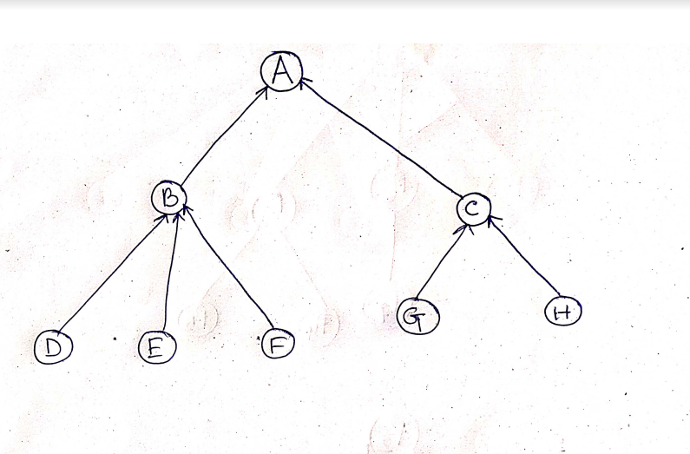**Input Tree Diagram**
      2. **Input File**

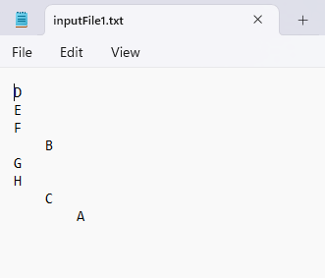

* + 1. **Output File**

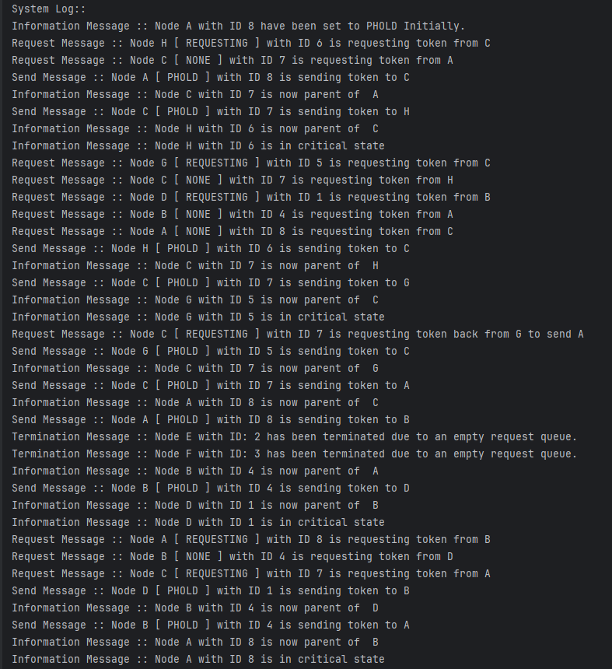

* + 1. **Output Tree Diagram**

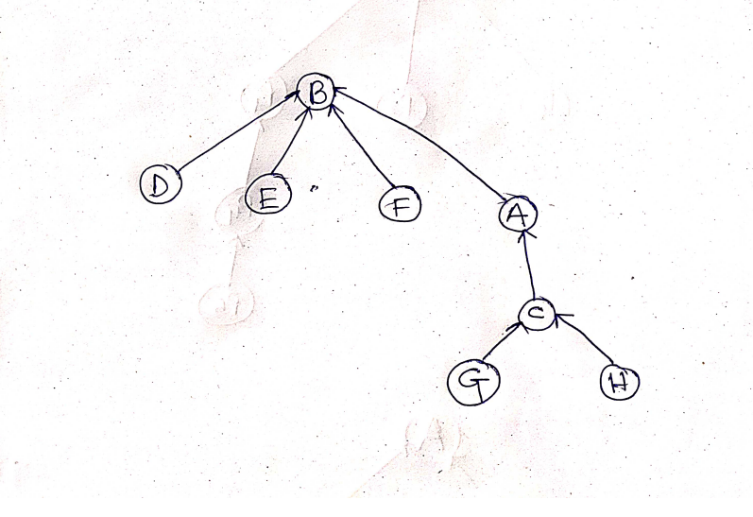

* 1. **Result 2**
     1. **Input Tree Diagram**

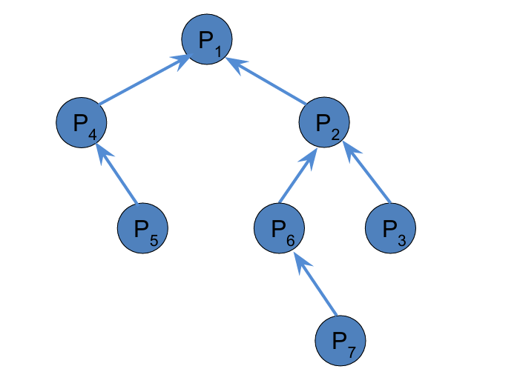

* + 1. **Input File**

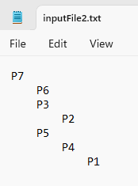

* + 1. **Output File**

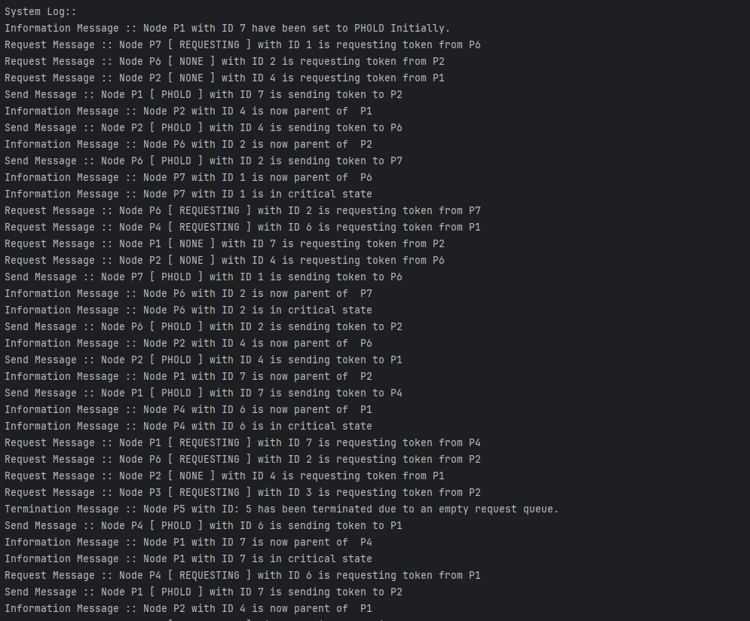

* + 1. **Output Tree Diagram**

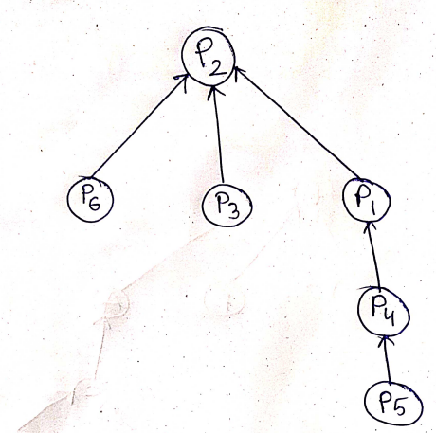

* 1. **Result 3**
     1. 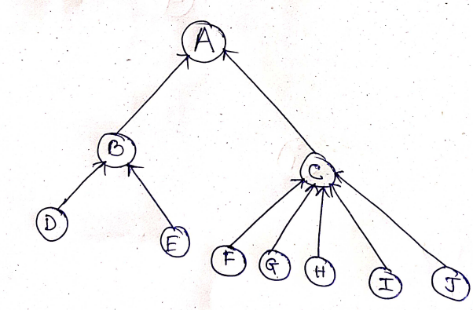**Input Tree Diagram**
     2. 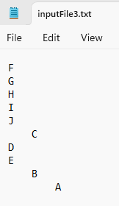**Input File**
     3. 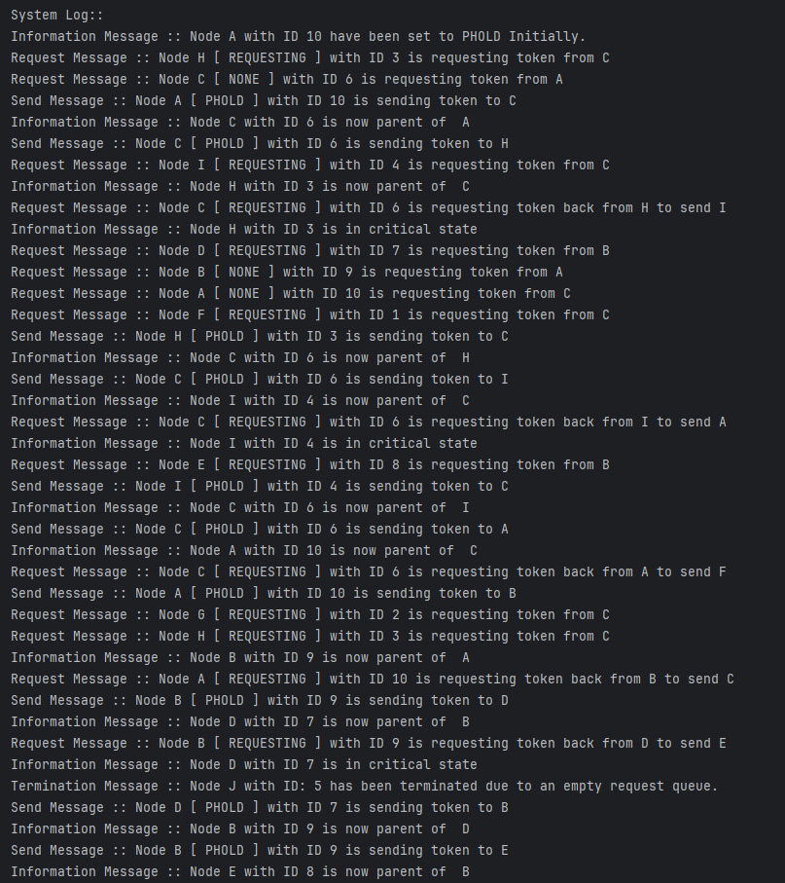**Output File**
     4. 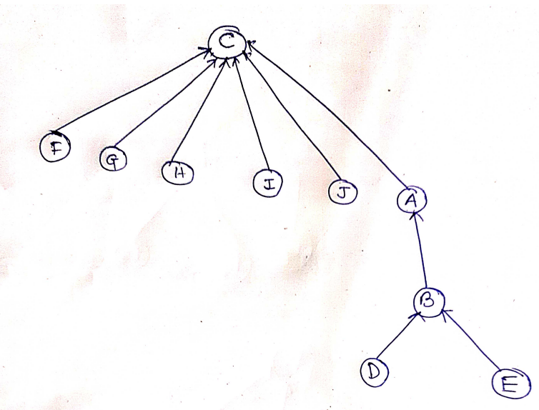**Output Tree Diagram**

** These screenshots are part of the output log files; the complete logs are available in the output folder.

1. **Remarks**
   1. **Structure and Functionality:** The code implements a hierarchical tree structure using Node objects to represent nodes with parent-child relationships. It reads input from a file, builds the tree structure using indentation levels, and manages node relationships using stacks and maps (HashMap and TreeMap).
   2. **Multithreading and Concurrency:** Multithreading is utilized to simulate concurrent processes (Node instances) in a distributed system. Each Node runs as a separate thread, interacting with its parent and potentially other nodes through token requests (requestToken() and sendToken() methods).
   3. **Error Handling and Logging:** The code includes basic error handling for file operations (IOException) and thread interruptions (InterruptedException). Extensive logging (System.out.println()) is used for debugging and providing information about node states, thread actions, and system messages.
   4. **User Interaction and Input Handling:** AWT (FileDialog) is used for user interaction to select an input file, ensuring flexibility in choosing the hierarchical structure to simulate.
   5. **State Management with Enums:** The Node class utilizes a Status enum (PHOLD, REQUESTING, NONE, ABORT) to manage node states, influencing node behavior during thread execution.
   6. **Optimization and Performance Considerations:** The code could benefit from optimizations in terms of memory usage and thread management, especially for large tree structures or high numbers of concurrent nodes. Performance considerations include ensuring efficient traversal and synchronization among threads to avoid potential race conditions or deadlocks.
   7. **User Instructions:** Before running the code, ensure the JDK is installed, and an appropriate IDE or text editor is set up for Java development. Prepare an input file formatted with nodes and indentation levels to simulate different hierarchical structures. Monitor the console output for detailed system messages, including node creation, thread actions, and final tree structure.
   8. **Abort Functionality in Node.java:** In the Node.java class, the ABORT functionality manages node termination based on specific criteria, utilizing the Status enum for state management. Nodes transition to the ABORT state when conditions such as prolonged inactivity (tracked by abortCounter) or system-wide failures (monitored via rootAbortCounter) occur. This feature is crucial for simulating realistic distributed system behaviors, where nodes may fail due to deadlock, resource exhaustion, or other critical issues. Upon entering the ABORT state, nodes cease operations, potentially terminating their threads and logging relevant termination reasons. This mechanism not only enhances the simulation's accuracy but also enables the exploration of recovery strategies and the impact of node failures on the overall distributed system dynamics.